Document For HCI Final Project
1352878 王泽宇
- Brief Description
I created a class named Folder. This class contains a String, which is used to store the name of the Folder. Class Folder also contains 2 constructor to create a brand new folder or a copy of a existing Folder.

public class Folder {
String name;
Static Integer folderNameIndex ;
public Folder() {
folderNameIndex++; //make sure new folders won’t have same name
name = "folder_" + folderNameIndex ;

}
public Folder(Folder folder) {
name = "Copy of " + folder.name ; //make a copy of a existing folder
}
}

I used an ArrayList< Folder > called folders to store all the Folder instances for we may delete or add some of them from or to different index , which is hard to implement by array or vector ,etc.

- The Implemented Requirements
I’ve implemented all the 9 requirements.
- The window is separated into two parts, the left part is used to show what was captured by the camera and show the hands that was detected from the image. The right part is used to place the folders, they are placed in order like a chart because I used 4 number to rule them : folderWidth , folderHeight , row and column
- By using the method of opencv, an instance of class openCV, detect(),I can get an array storing several Rectangle, then I just need to add these rectangles to the left part of window.
- I added 4 folders to folders in my code so that when the program is initiated there will be four folders
- I have 4 integer to store the position of the cursor:
Integer cursorX = 0;
Integer cursorY = 0;
Integer pcursorX = 0; //just like pmouseX
Integer pcursorY = 0; //just like pmouseY
And I call a function called getCursorXY() in draw() to update the value of these 4 integers every frame. When the program get the new value of these 4 , it will draw a hand on the screem ( with a little fix ).
- All of the folder are placed orderly so it’s easy to know which one is selected just according to the position of the folder picture and the position of the cursor. I wrote this process in draw(). The program will draw a picture of folder for every element in folders , if one element is the selected one, program will draw a pink-backgrounded folder puicture for it instead of the normal one.
- I add some code in draw() to check if the user presses C and the selected folder is not null. If so , check if there is already a folder has the same name with the new folder . If not , use the constructor of class Folder and use the selected folder as the parameter to create a copy of the selected one , than add it to folders.
- I add some code in draw() to check if the user presses M and the selected folder is not null. If so , remove the selected one from folders and draw it at the position of cursor and cursory.
- I add some code in draw() to check if the user presses N. If so , add a brand new folder into folders.
- I add some code in draw() to check if the user presses D and if the selected one is not null. If so , remove the selected one from folders.
- For all the 4 operation , I add a character to store what did user pressed in last frame.
Character pPress = 'a'; //with a default value ‘a’,it can be set to a d c n m
It will be refreshed every frame and ‘a’ means the user didn’t press any button in last frame. Because we if we press a button, we think it’s just one click but three frames has passed. For New or Delete, such thing is terrible, so I add this character to avoid such thing.
- Advantages And Disadvantages Of My Program
Advantage:
- Set cursorX, cursorY, pcursorX, pcursorY for the program to locate the cursor and satisfy any demand. Just like what Processing itself did to mouse cursor.
- Use ArrayList to store the folders so that the program can insert or delete folder from any index.
- Set pPress to store the last operation, avoid accidents from happening.
- Set deviationX and deviationY to store the deviation between the position of cursor and the position of folder so that when the folder is moving with the cursor, it looks natural.
- The picture that the program captured is reversed, not like what we see in a mirror. And if not all of you fist is in the picture, the OpenCV cannot detect it. So I wrote 4 functions so that you fist don’t need to reach the edge of the screen to move you cursor to the edge.
Integer cursorYTrans(Integer y){
return y*3/2;
}

Integer cursorYReverseTrans(Integer Y){
return Y*2/3;
}

Integer cursorXTrans(Integer x){
return 1440-x*5/3;
}

Integer cursorXReverseTrans(Integer X){
return (1440-X)*3/5;
}
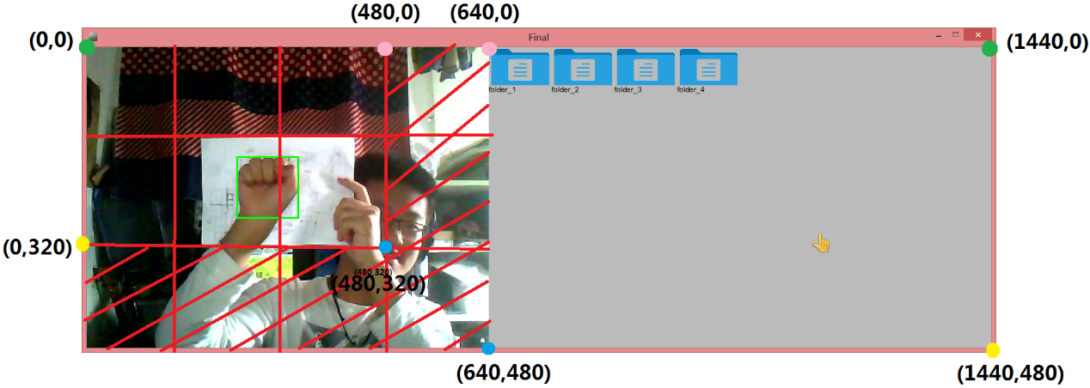
By using these function, I can transform the position of fist to the position of cursor or do the reverse. The blocks that is covered with red shadow is dead zone, in which the fist may not be detected, so everything can be done in the rest of block. The points that are in same color should be one-to-one mapped and this can be done through these for functions.
- It’s hard to decide which one to be the cursor if more than one fist is detected and it’s also frustrating if nothing is detected, so I created some rules:
- If nothing is detected, nothing will be done.
- If no fist has been detected before, choose the biggest fist as the first one.
- If the distance between a detected fist and the finally chosen fist in last frame is less than 1750^0.5, add this fist to candidate ArrayList. If the candidate ArrayList is empty, regard this frame as nothing is detected. If not, choose the one in the candidate ArrayList who has the smallest distance as the finally chosen fist.

Disadvantage:
The aGest.xml that we got is not good enough for openCV to detect fist accurately, sometimes it ignore my fist and sometimes it regard other things as a fist, like a mouth or an eyebrow. Taking a piece of white paper as the background of fist will strongly improve the situation.
- How To Improve My Program
All needed to do is getting a better aGest.xml.

1352878 王泽宇
2015.06.20

